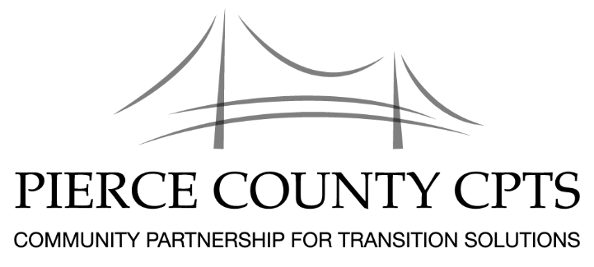

Pierce CPTS Agenda

August 3, 2018
Location: Bates Technical College, 1101 S. Yakima Ave., Tacoma, WA 98405
Room: Clyde Hupp Board Room – A329
Time: 10:00am – 12:00pm

Pierce County Community Partnership for Transition Solutions
Vision Statement  Mission Statement | A community that welcomes the talents and contributions of all members, including those returning to us from prison and jail.  Our mission is to promote the successful reintegration of individuals into community. We accomplish this through purpose driven community partnerships that provide holistic, comprehensive services in support of these individuals as they build self-sufficient and productive lives.

Agenda
10:00 - 10:15  10:15 – 11:30 | Brief Introductions: Name, Organization, Who you serve  - Back to School Drives  - National Alliance of Incarcerated or Formally Incarcerated Women and Girls – N2N  - Summer Institute, August 23rd and 24th  - 2018 Pierce County Awards – if you would like to nominate an individual or agency please email their name and a bio of their work to piercecpts@gmail.com  - Hilltop Street Fair, August 25th  - New facilitator opportunities  - Partner Announcements  Rapid Refilling and Refreshments
11:30 – 12:00 | Networking
Our next meeting: September 7, 2018

Location: Bates Technical College, 1101 S. Yakima Ave., Tacoma, WA 98405
Room: Clyde Hupp Board Room A329

