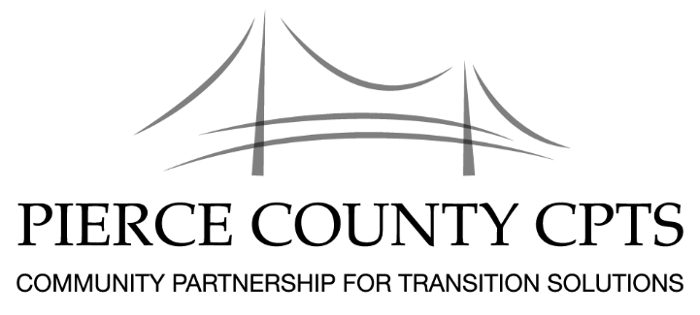

Pierce CPTS Agenda

November 2, 2018
Location: Bates Technical College, 1101 S. Yakima Ave., Tacoma, WA 98405
Room: Clyde Hupp Board Room – A329
Time: 10:00am – 12:00pm

Pierce County Community Partnership for Transition Solutions
Vision Statement  Mission Statement | A community that welcomes the talents and contributions of all members, including those returning to us from prison and jail.  Our mission is to promote the successful reintegration of individuals into community. We accomplish this through purpose driven community partnerships that provide holistic, comprehensive services in support of these individuals as they build self-sufficient and productive lives.

Agenda
10:00 - 10:15  10:15 – 11:30 | Brief Introductions: Name, Organization, Who you serve  - New Facilitator: Welcome – Sean Raybell, Regional Housing Specialist, Washington State Department of Corrections  - Would you like to be a facilitator? Request an application packet.  - WCCW reentry resource fair on Nov 8th, from 12:30 to 2:30  - Cedar Creek resource fair on Nov 16  - WCC-Shelton resource fair on Nov 28th, from 1p to 3p  - TROC will be having their Holiday Winter Fest in early Dec. Details coming.  - Unguarded Art Show is in the works, more details to come  - Partner Announcements  - At our December meeting, we will have an Appreciation Ceremony, hope all of you can join  Rapid Refilling and Refreshments
11:30 – 12:00 | Networking
Our next meeting: December 7, 2018

Location: Bates Technical College, 1101 S. Yakima Ave., Tacoma, WA 98405
Room: Clyde Hupp Board Room A329

